VEND Instructions:

* We have changed the format of collecting payments and tried to simplify them as best as we can. See details below. I recommend working with the 4H PC (or designated person) in your office to determine what registration product to use for each attendee.  Also, ***please be sure you or your office are keeping good records and tracking payments received, scholarships, etc for all attendees in your office. I believe Exploration Days provides tools for this.***
* Please keep in mind that we make every attempt to assist with record keeping; however, ***VEND is a cash receipting system, not a registration system.***

**Expo Days- payments**

* On each Exploration Days transaction, the CUSTOMER entered needs to be the attendee. This will help when your office periodically run reports by customer to see what has all been collected and then what remains outstanding.
* List of products to record 2019 YED sales are provided in the chart below, with SKU # for ease.  A folder of quick keys for 2019 Youth Exploration Days should appear on your sale screen already (or very soon) which has these products.
* Registration options- below are the options available and you can only choose 1. Please be sure you are determining if the attendee is:
  + Paying the full $220
  + Paying $175 by receiving a $45 Award Assembly scholarship
  + Paying $180 by receiving a $40 Financial Assistance Scholarship
  + Paying $135 by reciving both $45 and $40 Scholarships
  + Paying zero because they are an Instructor, Instructor Helper or CCA.
    - For questions related to the correct registration item, please contact your 4H PC or designated person
    - **Scholarships beyond the $40 and $45 listed above can still be applied to registrations**
* For the products with cost per item at $1, to change the total received, change the quantity.
* If clubs/councils/other entities provide scholarships and there are attendees associated to them, simply enter a sale under the attendee name for the product which the scholarship is being applied to (registration or fee).  Example: *Farm Bureau gives a check for $1,000 and states 10-$100 scholarships for registrations.  There will be 10 VEND transactions created under each attendee name as the customer.*
* ***If scholarships are received or located in MSU accounts, a request with detailed information of name, amount and account for each person should be sent to the business office (***[***msue.busoffice@msu.edu***](mailto:msue.busoffice@msu.edu)***)  for processing.***

If clubs/councils/entities provide scholarships and there are no users to tie the payments to when the funds are received, then you should be depositing these funds to your local gift account with the gift form. This is where it will be important for your office and record keeping.  When the time comes to apply these gifts/donations to an attendee’s account, you can make the request with detailed information of name, amount and account for ***each person*** should be sent to the business office ([msue.busoffice@msu.edu](mailto:msue.busoffice@msu.edu))  for processing.

|  |  |  |  |
| --- | --- | --- | --- |
| SKU | Product Name | Deposit to Acct | Cost per item |
| 2018-19 Youth Participation Fee | | | |
| 10725 | Participation Fee - 1st - 3rd Kid | County 4HHLD | $ 20.00 |
| 10726 | Participation Fee - 4th or more | County 4HHLD | $      - |
| Registration Types - Only choose ONE | | | |
| 10712 | Youth and Chaperone Full Registration                                              $220 Due | DS100010 1202 4080 | $   1.00 |
| 10794 | Registration with $45 Award Assembly Scholarship                         $175 Due | DS100010 1202 4080 | $   1.00 |
| 10795 | Registration - $40 Financial Assistance Scholarship                            $180  Due | DS100010 1202 4080 | $   1.00 |
| 10824 | Registration - $45 and $40 Scholarship                                                    $135 Due | DS100010 1202 4080 | $   1.00 |
| 10704 | Instructors, Instructor Helpers and CCA's -                                                No Fee | DS100010 1202 4080 | $      - |
| Exploration Fees | | | |
| 10718 | Access Card Replacement Fee                                                                          $10 | DS100010 1202 4080 | $ 10.00 |
| 10708 | Youth and Chaperone Early Arrival Fee -                                                  $35 due | DS100010 1202 4080 | $ 35.00 |
| 10710 | Session Fees- Amount Due Varies | DS100010 1202 4080 | $   1.00 |
| 10721 | Plus Size T-Shirt Fee                                                                                            $5 | DS100010 1202 4080 | $   5.00 |
| 10799 | Instructors, Instructor Helpers and CCA's Early Arrival Fee-                     No Fee | DS100010 1202 4080 | $      - |
| 10722 | Key Replacement Fee                                                                                        $75 | DS100010 1202 4080 | $ 75.00 |
| Local County Fees | | | |
| 10719 | Local County Fee Charged- Amount Varies | CYIAC 4080 | $   1.00 |

**Running sales reports: (example below)**

**Report type:** Customer

**Date Range:** Whatever time period you are reviewing

**Filter:** 2019 Youth Exploration Days **“PRODUCT TYPE”**

**Filter:** Your county Register with account (example: Ingham DS100133)

**Show Products:** Check box and this will itemize products entered under each customer.

Below is an example of what the sales reports will look like.

**Faith Todd**: This person appears to be all set.  Registration amount adds up to the full amount and there is an early arrival fee. The only thing left would be session fees or other county fees assigned.

**Jessica Peters:** This person also appears to be all set.

**Samantha Meek:** This person still owes $40.  They have paid $180 and the registration total $220.

**Dana Fracalossi:** This person owes $45. They have paid $175 and the registration totals $220.

If the amount owed is paid by scholarship (and housed in a MSU account on Campus) there will always be an amount showing due on the sales report.  This is where your record keeping will come into play.

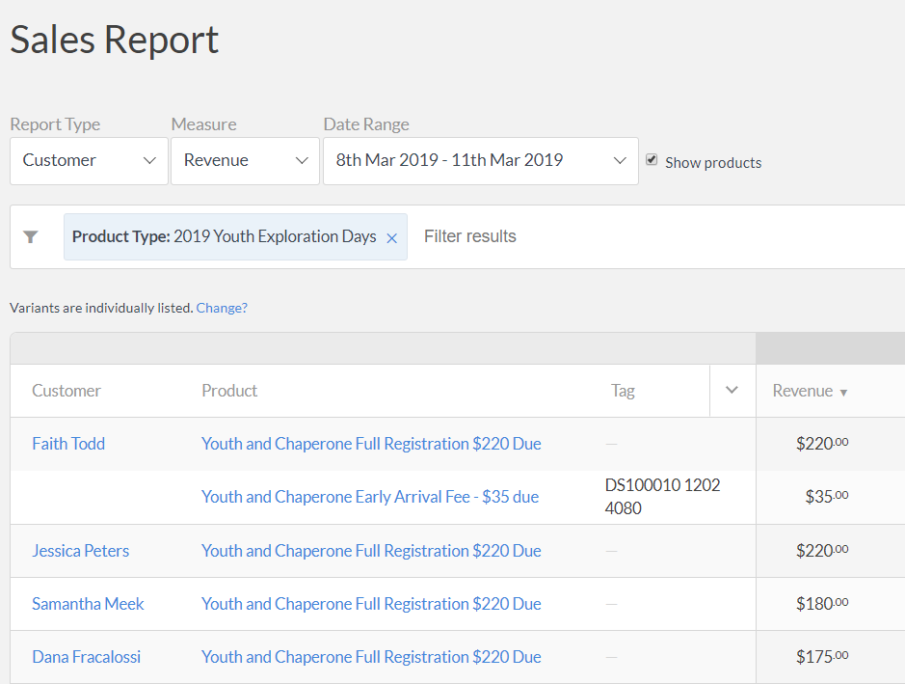

**Kelli Kolasa**

VEND Cash Register Administrator

[**MSU Extension Business Office**](http://www.canr.msu.edu/od/business_office/)446 W. Circle, Room 160

East Lansing, MI 48824

[msue.vend@msu.edu](mailto:msue.vend@msu.edu)

M-F 7:30 am - 4:00pm